* Launching Data

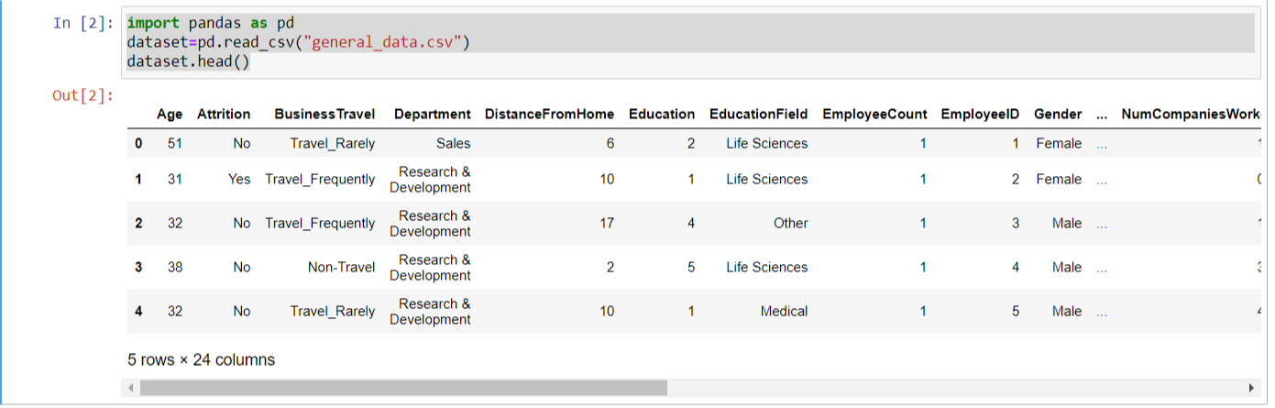

Lets verify Age is Normalized or Not

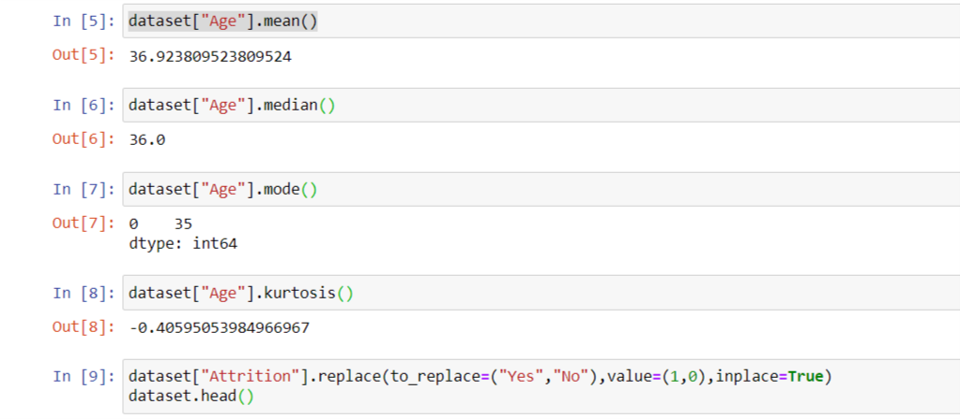

From above data we can say that age is not normalized

2.we should put Age of employee and Attrition on test to view any how Age is related on Attrition . as we know that Age is continuous variable and Attrition is Categorical variable we can use mann whitneyu test to Check is there any variation mean age with respect to Attrition.

First of all we convert **Yes And No** Attrition value to **0,1** respectively.

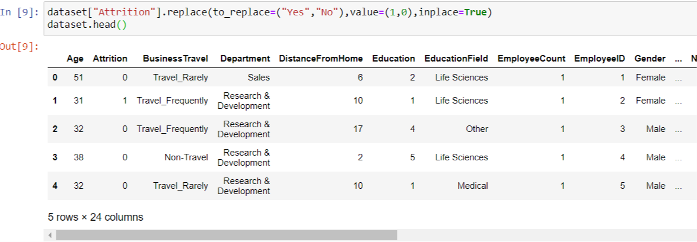

* Mann whitenyu test of Age with respect to Attrition :

Lets split data according to Attrition.

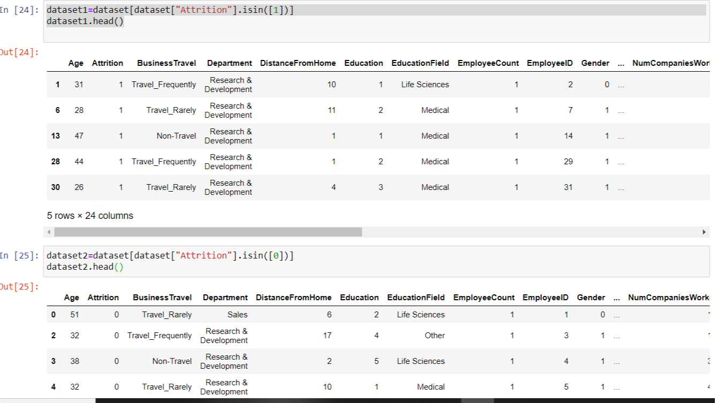

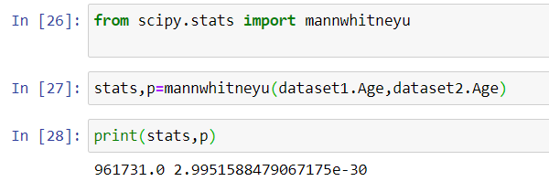

From Above test result we can see that p <0.05 so reject null hypothesis,

So there is significance difference between Age with respect to Attrtion.

* Mann whitneyu Test of Percent salary hike with respect to Gender :

Lets verify is percent salary varies with respect to gender of employee.

First of all convert gender male and female as 0,1



Lets splits dataset according age :

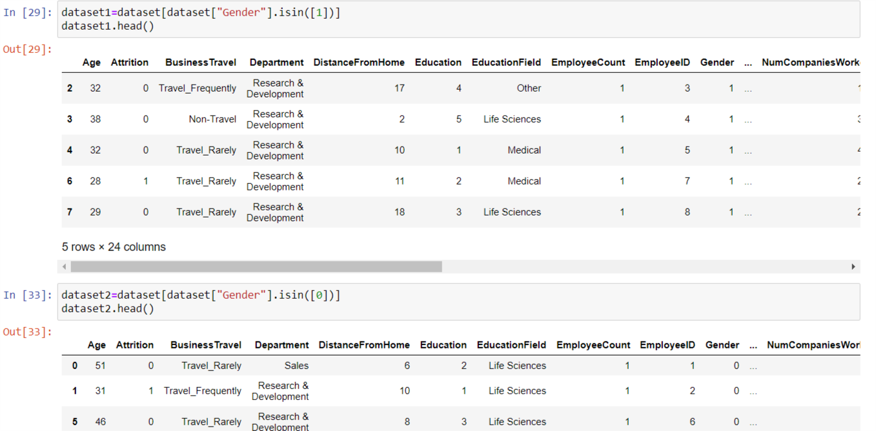

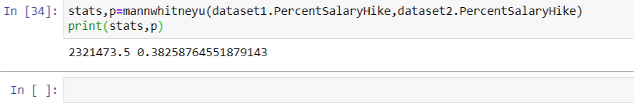

From Above test result we can see that p > 0.05 so accept null hypothesis,

So there is no significance difference between PercentSalaryHike with respect to Gender.

* Mann whitneyu Test distance from home and Attrition :

Lets split data according to Attrition.



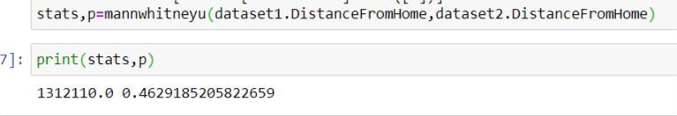

From Above test result we can see that p >0.05 so reject null hypothesis,

So there is no significance difference between Distance from Home with respect to Attrition.

* Kruskal Wellies test for Age with respect to Education fields :

Lets splits age column with respect to Education Field.

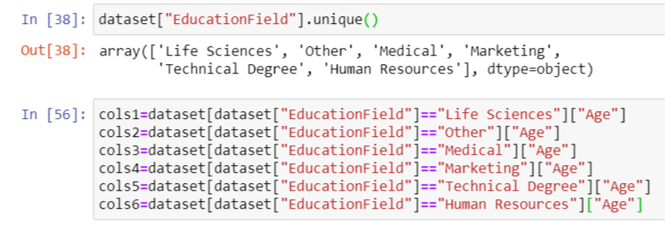

Lets perform test :

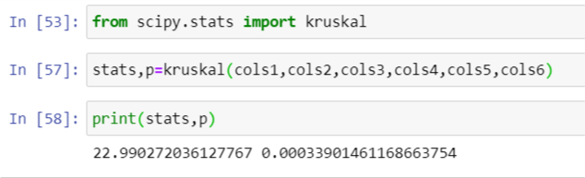

From Above test result we can see that p < 0.05 so reject null hypothesis,

So there is significance difference between Ages with respect to Education Fields.

Kruskal Wellies test for Percent Salary Hike with respect to Education Level :

Lets splits Percent salary Hike column with respect to Education Field.



Lets perform test :

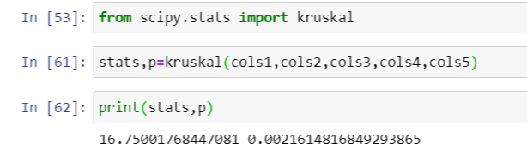

From Above test result we can see that p < 0.05 so reject null hypothesis,

So there is significance difference between Percent salary Hike with respect to Education Level.